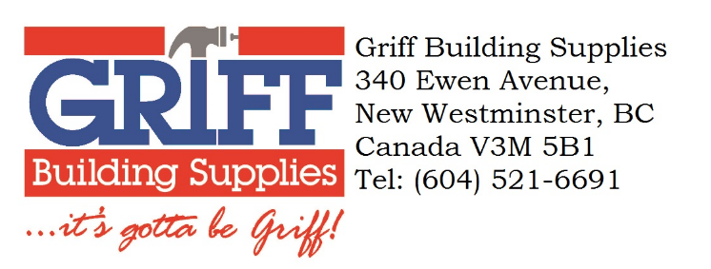

CALIFORNIA PROPOSITION 65 – WOOD DUST / CHEMICAL PRESENCE WARNING

Dear Valued Customer:

California’s Proposition 65, officially known as the Safe Drinking Water and Toxic Enforcement Act of 1986, states that no person in the course of doing business shall knowingly and intentionally expose an individual to potentially hazardous chemicals without first providing a clear and reasonable warning.
As a Distributor of Wood Products, Griff Building Supplies Ltd. (“Griff”) hereby informs you that wood products may expose individuals to chemicals such as methanol and wood dust, both natural components of wood. Any company that offers such products for sale in California or manufacturers products in California should display the attached warning sign “either at the point of sale or display of the wood products in a manner likely to be seen by the purchaser. The notice or sign must be no smaller the 8 ½ by 11 inches and printed in no smaller than 20-point type.”

WARNING:
Drilling, sawing, sanding or machining wood products can expose you to wood dust, a substance known to the State of California to cause cancer. This product (excluding Lumber) can expose you to chemicals including methanol, which is known to the State of California to cause birth defects or other reproductive harm. Avoid inhaling dust generated from wood products or use a dust mask or other safeguards for personal protection. For more information, go to www.P65Warnings.ca.gov

Thank you for your attention to this important requirement, and please contact us with any questions about our products.

